OSFP

*Name: Muhammad Maaz Khan*

*Class: Se-5B Roll: Se-221053*

*Course:* ***Computer Networks***

*By* ***Sir Wilayat***

**OSPF (Open Shortest Path First)** : A dynamic routing protocol used in IP networks for finding the best path between routers.  
  
  
  
  
We will create a topology with **three routers** (R1, R2, R3) and **three PCs** (PC1, PC2, PC3). The routers will be connected in a triangular fashion to demonstrate OSPF's ability to find the shortest path dynamically.  
  
  
It is a **link-state protocol** and works within a single **Autonomous System (AS)**.  
  
  
OSPF divides the network into **areas** (e.g., Area 0), reducing the size of routing tables and making routing efficient.  
  
  
  
  
  
  
  
  
  
  
  
  
  
  
  
  
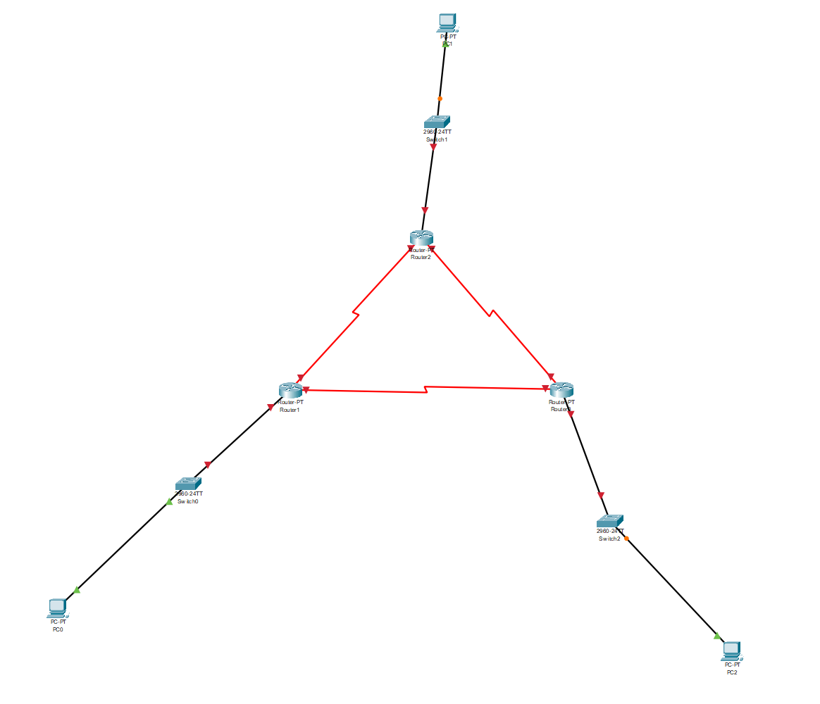  
  
  
  
  
  
  
  
Configuration of R1  
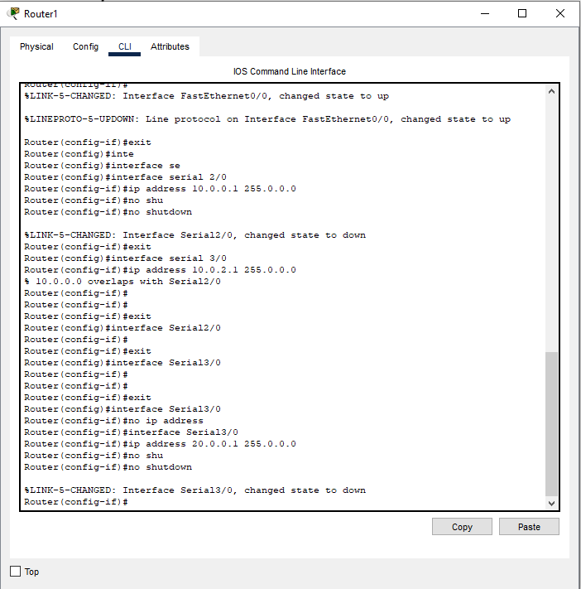  
  
  
  
  
  
  
  
  
Configuration of R2  
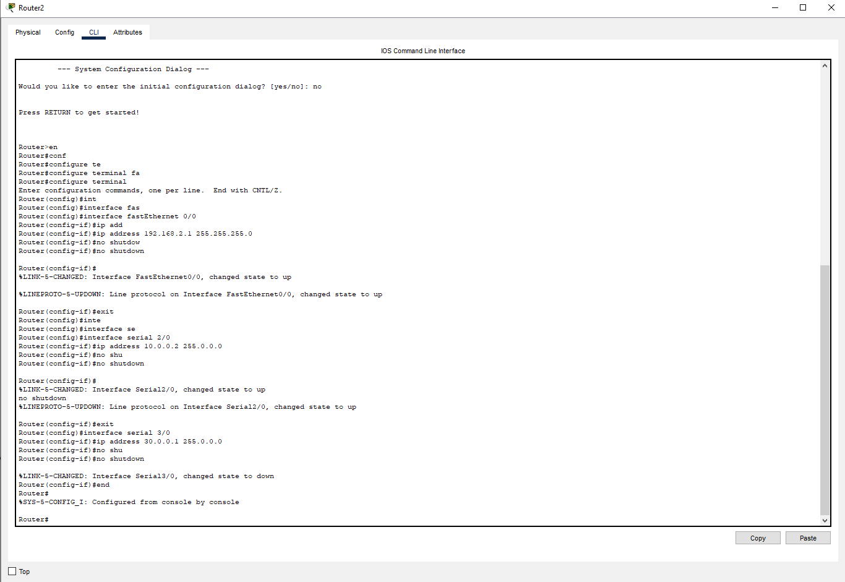  
  
  
  
  
  
  
  
  
  
  
  
Configuration of R3  
  
  
  
  
  
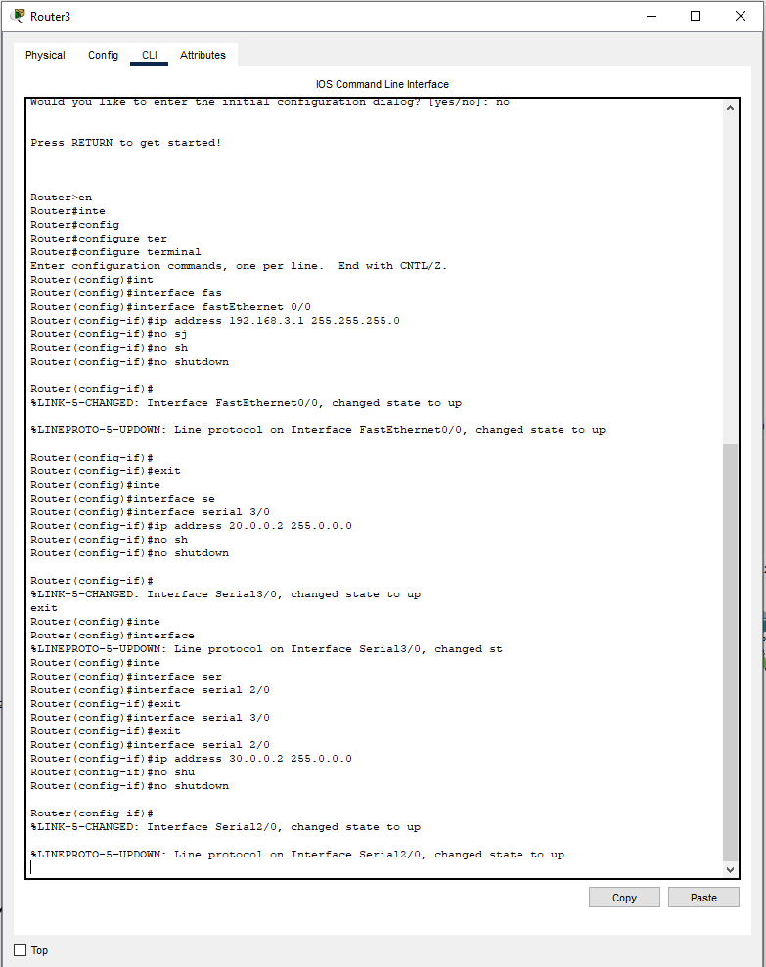  
  
  
  
  
  
  
  
  
  
  
  
  
  
  
  
  
  
  
  
  
  
  
  
  
  
  
  
  
  
  
  
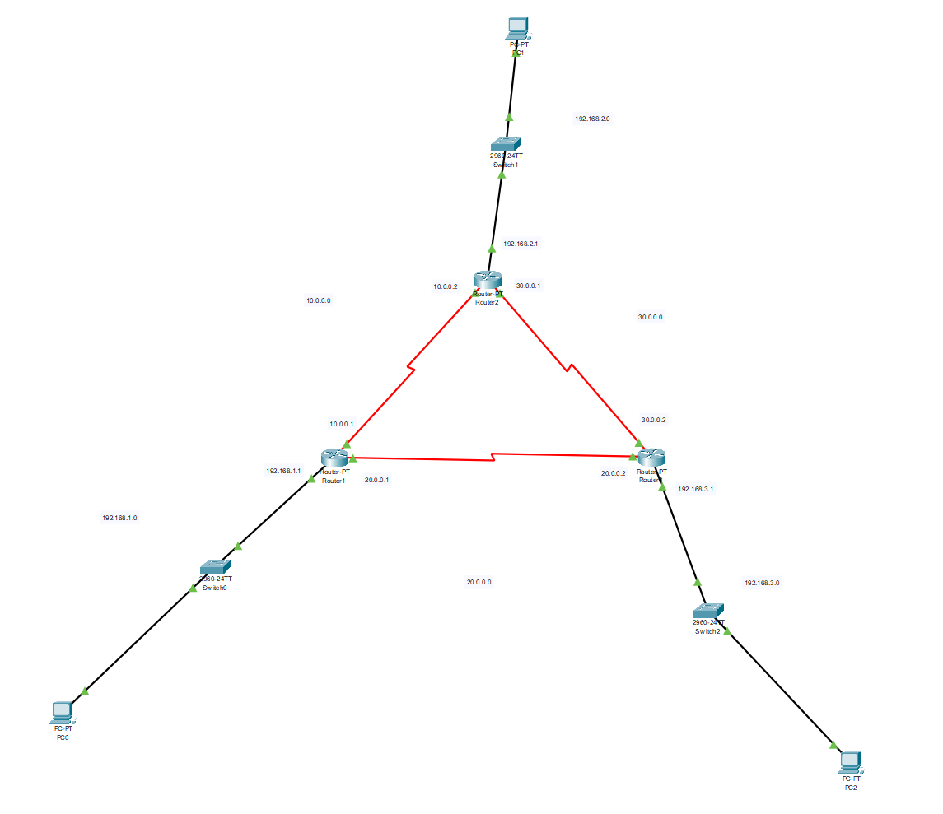  
  
  
  
  
  
  
  
  
  
**Enter OSPF Configuration Mode:**On each router, use the command:  
  
  
  
Router 1:  
  
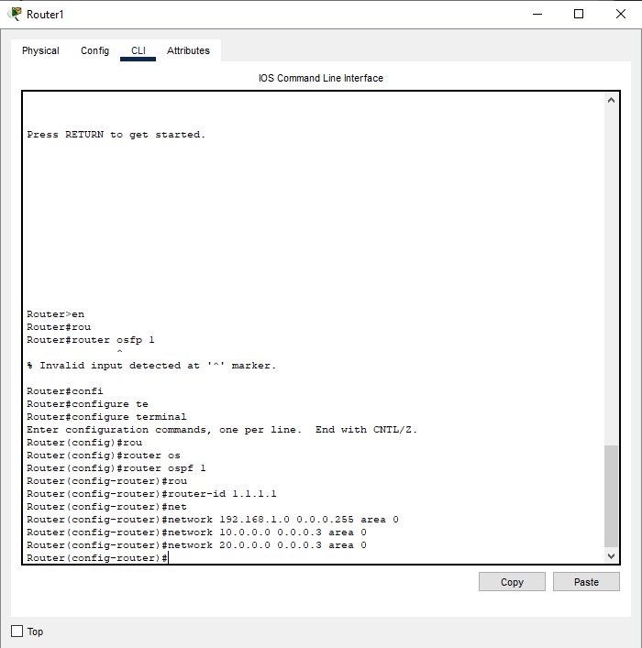  
  
  
Router2:  
  
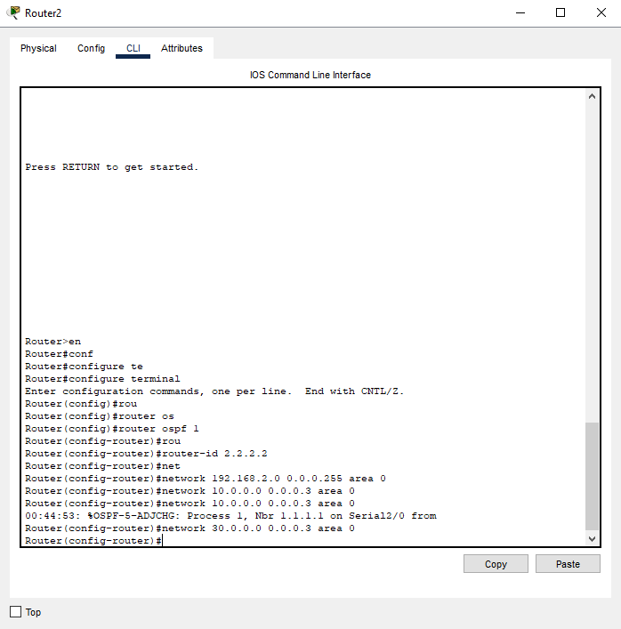  
  
  
  
  
  
Router3:

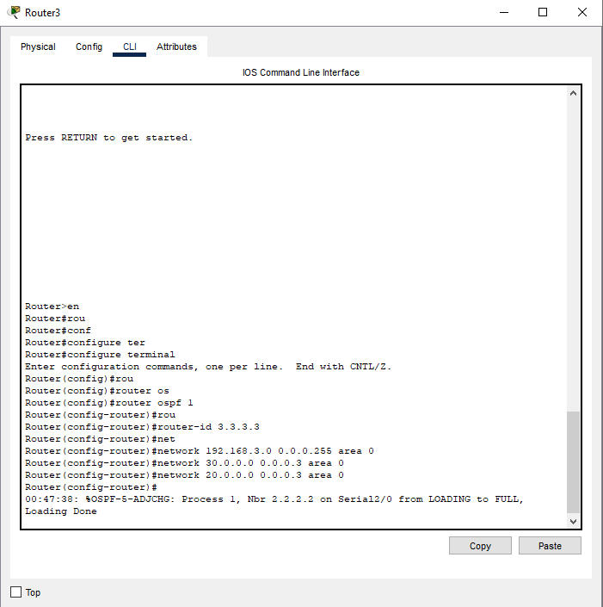  
  
  
  
  
  
  
Verify OSPF Configuration:  
  
  
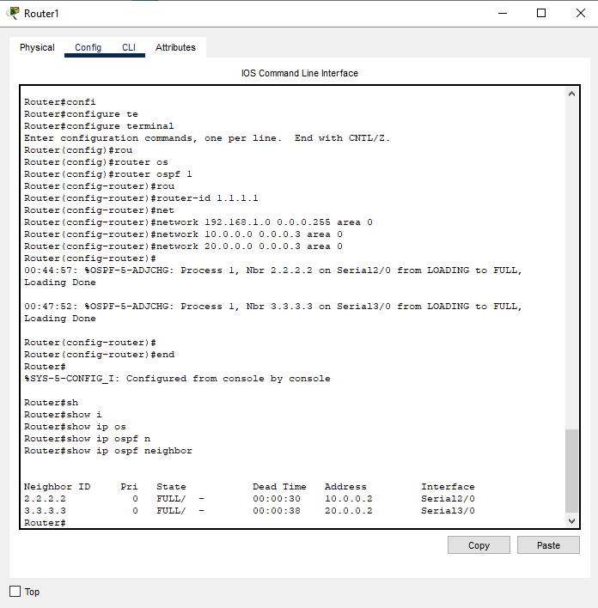  
  
  
  
  
  
  
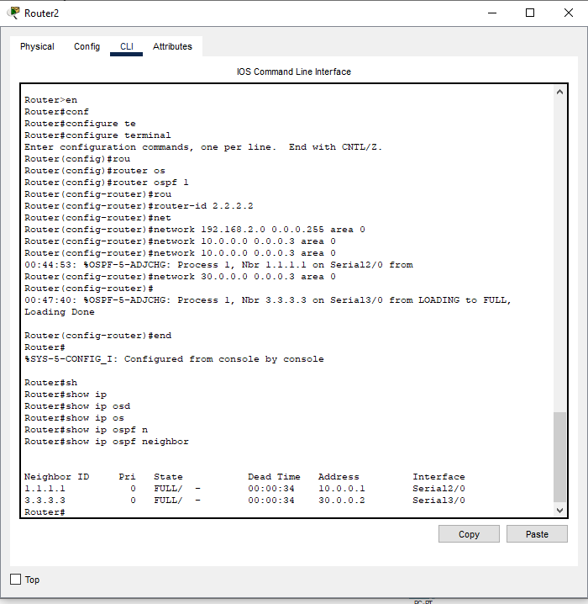  
  
  
  
  
  
  
  
  
  
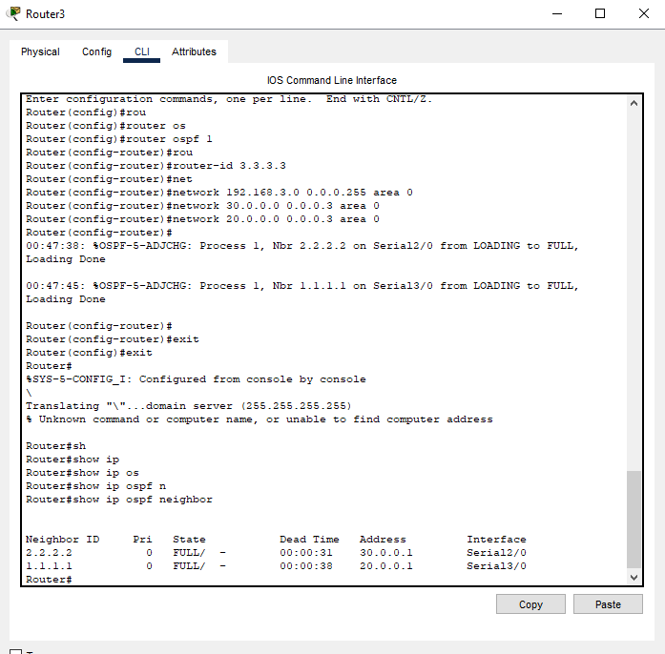  
  
  
  
  
  
  
  
  
  
Test End-to-End Connectivity:  
  
From **PC1**, ping **PC0**: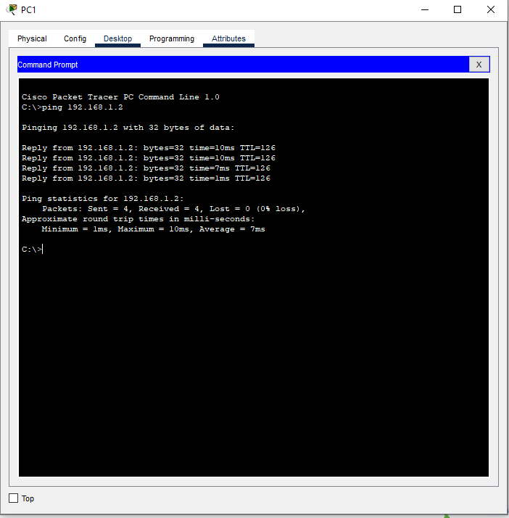  
  
he successful ping from **PC1 (192.168.2.2)** to **PC0 (192.168.1.2)** confirms that OSPF is routing the traffic correctly. This shows that all configurations are working as intended, and devices across different subnets can communicate seamlessly.